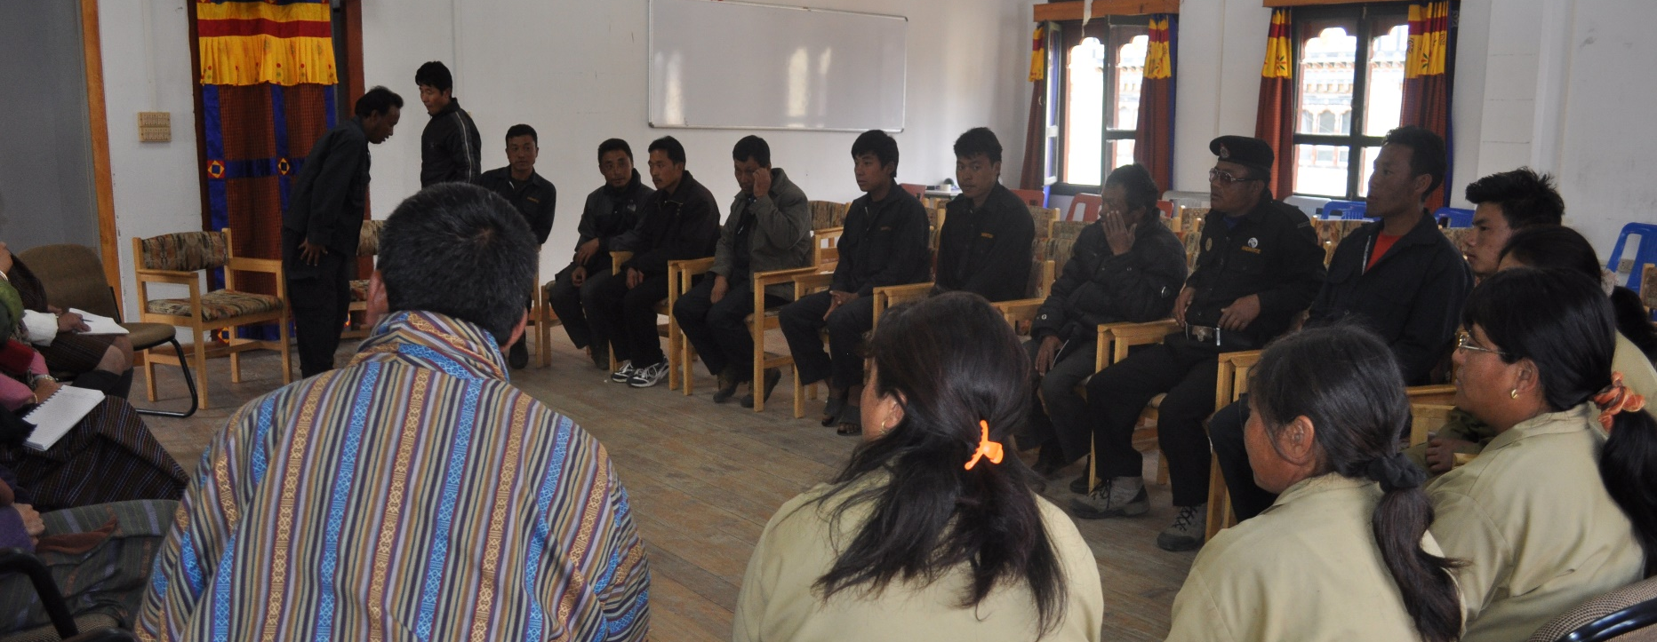
Replace the photo in the background with your own project relevant photo and add the photo credit at the end of the document.

IF USING MS WORD: to replace the photo select the existing photo, click the picture tools/format tab at top bar, click “Change Picture” and select from file. Crop if needed (far right of picture tools). If photo is stretched, click the “Crop” dropdown button and select “fill” to reset proportions.

Delete this instruction text box.
POLICY BRIEF

TITLE OF POLICY BRIEF Action-oriented title conveys why topic matters.
Summary Summarize the policy brief’s content in one to two short paragraphs. Be sure to state why the issue is important, highlight the findings, and indicate the actions you recommend. Unlike a journal article, a policy brief usually presents the summary of conclusions and recommendations in the first couple of paragraphs. You want readers to know up front what the research findings are and their implications—just enough to whet their appetites to read the whole brief.
Make sure your first paragraph provides the communication objective that describes the purpose or reason for sharing this information with your target audience(s). The objective should be related to your research findings or technical innovation.
Background Background paragraph should provide relevant contextual information and explain why this issue is important. Identify the necessary context to support your discussion of the key findings and recommendations, keeping in mind your audience and their interests. You should state what previous research has shown or what past policies/programs have (or have not) achieved. Remember to focus most on the details that tie into your key findings and implications.
Result Your key research findings contextualized by their implications make up the main body of your policy brief. Divide your findings into subsections that walk the reader through the story you want them to understand. The main messages you have developed around the findings, implications, and recommendations become subheadings for each subsection and help you organize the main body of your policy brief.
Explain why the research findings are important for policies, programs, or technical practices—these are your policy implications. They speak to your audience about why they should care about the issue and the recommendations you make. For example,
- What policy or program issues arise from the findings?
- Are there underlying causes to be addressed?
- Is the evidence sufficient to support action now?
- Have solutions been tried? Were they effective?
Your implications— the heart of the policy brief—are the bridge that interpret and contextualize findings on the issue. They make connections to the recommendations.
Try to create an equal relationship between your key-finding headings and policy-implication headings as well as your recommendation headings. One key finding + one policy implication = one recommendation. This parallel structure creates a strong relationship and tight organization that helps your audience understand the issue and what you want them to do.
Use tables and figures to enhance the discussion. Use valuable word space to talk about why what your audience sees in a figure is significant. Tables and graphs should be used to call attention to and better inform key data points. Discuss how data in the figure supports your key findings and policy implications. Keep in mind, however, that not every key message needs to be accompanied by a data or figure. Use graphics that will best illustrate and emphasize your policy brief’s messages.
[INSERT TABLE OR FIGURE]
Recommendations: Recommendations flow from the evidence presented. Identify specific interventions or actions needed, and by whom. Your findings should support the recommendations, as should other literature/experience on the topic.
Write SMART recommendations (Specific, Measurable, Action-Oriented, Realistic, and Timebound).
REFERENCES
Use a reference guide (such as AP or Chicago) depending on any organizational affiliation or guidelines you must follow.
- Reference
- Reference
- Reference
- Reference

Logos

Contact: [author name], [Department/Division], [College/Department], Royal University of Bhutan], Email: [email]. For further details, please see [‘enter article title’], Working Paper No. [ ] at [website where the paper is published].

